**I.K.G Punjab Technical University**

**B-Tech Batch 2018 Onward**

**Summer Training Project Report**

ON

**ArtStore ( E – commerce website )**

**Submitted to**



**I.K GUJRAL PUNJAB TECHNICAL UNIVERSITY**

**KAPURTHALA**

In Partial Fulfillment of The Requirement for the Award of degree

**Of**

**Computer science Engineering (CSE)**

**SUBMITTED BY**: **SUBMITTED TO:**

**NAME:** Anurag kohli **Name**: Ashish Kumar

**B-Tech** CSE(7th) **Design**: Hod

**ROLL NO**: 2202862

Computer science Engineering/ Electronics & comm. Engineering

DOABA INSTITUTE OF ENGINEERING AND TECHNOLOGY, Kharar

MOHALI

BATCH(2022-25)

|  |
| --- |
|  |

# *DECLARATION*

I hereby declare that the Project report titled ArtStore: An E-Commerce Platform for Art Reproductions is my original work and has not been published or submitted for any degree, diploma or other similar titles elsewhere. This has been undertaken for the purpose of partial fulfilment of B-Tech (Computer Science Engineer)

NAME: Anurag kohli

ROLL NO: 2202862

|  |
| --- |
|  |
|  |

**PREFACE**

This project report attempts to bring under one cover the entire hard work and dedication put in by me in the completion of the project work on “**ArtStore: An E-Commerce Platform for Art Reproductions “**.

I have expressed my experiences in my own simple way. I hope who goes through it will find it interesting and worth reading. All constructive feedback is cordially invited.

**ACKNOWLEDGMENT**

It is really a matter of pleasure for me to get an opportunity to thank all the persons who contributed directly or indirectly for the successful completion of the project report, “**ArtStore: An E-Commerce Platform for Art Reproductions**.”.

First of all I am extremely thankful to my university

**Doaba group of College** for providing me with this opportunity and for all its cooperation and contribution. **.** I am highly thankful to our respected project guide for giving me the encouragement and freedom to conduct my project.

I am also grateful to all my faculty members for their valuable guidance and suggestions for my entire study.

I would also like to thank the Computer Park team for extending their valuable time and cooperation.

Anurag kohli

Roll No: 2202862

**CONTENTS**

1. Acknowledgement .......................................
2. List of Tables ..............................................
3. CHAPTER 1 INTRODUCTION ...........................   
   1.1 Introduction ..........................................   
   1.2 Problem Statement ................................   
   1.3 Significance of the Study .....................
4. CHAPTER 2 LITERATURE REVIEW ..................   
   2.1 Overview of Previous Work ....................   
   2.2 Current Trends in E-Commerce ..............
5. CHAPTER 3 PRESENT WORK ..........................  
   3.1 Problem Formulation ..............................   
   3.2 Objectives ..............................................   
   3.3 Methodology ..........................................  
   3.4 Platform Used ........................................
6. REFERENCES ................................................

**CHAPTER 1**

**INTRODUCTION**

### **Introduction**

The development of technology has had a profound impact on the planet. E-commerce has completely changed retail, resulting in extremely convenient shopping. A large portion of the art market, art reproduction, has historically only been available through actual galleries and auction houses. However, as the popularity of online shopping increases, there is a rising demand for niche platforms that appeal to art lovers.  
  
  
Our initiative, ArtStore, aims to close this gap by establishing an online store selling premium art replicas. Our extensive collection of artwork will encompass many genres and historical periods, making it possible for clients to find, purchase, and appreciate art from any location.  
  
  
Additionally, ArtStore gives vendors and artists the ability to show off their creations to a larger audience, which increases their market reach. This document describes our goals, approach, and the technology we used to develop ArtStore.

### **1.2 Problem Statement**

Even though there are a lot of e-commerce sites out there these days, there is a clear need in the industry for sites that only sell art replicas. The majority of general e-commerce websites provide a broad range of products, which limits the exposure of sellers of art reproductions. Additionally, consumers who are interested in art reproductions frequently have trouble discovering reliable vendors that offer superior copies of original artwork.

Furthermore, a whole range of services tailored specifically to art buyers—like in-depth curation, artist biographies, and personalization options—are sometimes absent from existing platforms. As a result, customers may have to rely on several sources to obtain all the information they need on a work of art, creating a fragmented purchase experience. Consequently, a specialized platform that solves these issues and provides buyers and sellers with a targeted and well-integrated marketplace for art replicas is obviously needed.

### **1.3 Objectives**

The following are the main goals of ArtStore: An E-Commerce Platform for Art Reproductions:

• To develop a specialized online store that offers only premium art reproductions for sale and distribution.

• To offer a user-friendly interface that enables customers to explore, filter, and buy art reproductions by different artists and genres.

• To incorporate smooth and secure payment mechanisms to guarantee user confidence when making purchases.

• To promote trust and openness by providing comprehensive information about original creators and reproduction artists in artist profiles.

• To put in place a recommendation system that assists users in finding artwork by taking into account their browsing habits and preferences.

• To provide users with the ability to choose print sizes, frame options, and additional features for the reproductions that they can customize.

• To give merchants effective tools for handling their sales, inventory, and client relations.

## CHAPTER 2

**LITERATURE REVIEW**

### **2.1 E-Commerce in the Art Market**

E-commerce sites have completely changed the retail industry by giving a large audience access to a huge range of goods, including art. Global markets are now accessible to artists and art sellers thanks to websites like Amazon, Etsy, and eBay. Nevertheless, these platforms mainly serve a broad clientele and provide a restricted range of services designed with art sales in mind. The distinctive clientele that makes up the art market—people who value customization, authenticity, and curation—often defines it. Research indicates that although the demand for platforms dedicated to art has not decreased, the growth of online art sales appears to have been consistent.  
Scholars have investigated the difficulties in the digital art market, including guaranteeing the authenticity of artwork, offering an immersive experience for viewers, and serving both known and up-and-coming artists. Specialized platforms that concentrate on the subtleties of the art market can better meet the demands of both buyers and sellers, as noted by (Author Name, Year).

### **2.2 Art Reproduction Industry**

A way for people to appreciate well-known artwork without having to pay the premium price for originals is through art reproductions. The art reproduction market has been examined in a number of studies, with a focus on the elements that affect consumers' confidence when buying replicas online. As per (Author Name, Year), establishing client confidence is greatly aided by the provision of comprehensive details, including the original artwork's history and the credentials of the replica artist.   
Furthermore, studies show that offering customized choices—like picking various sizes, materials, or framing styles—can greatly increase client satisfaction (Author Name, Year). The value of high-resolution photos and augmented reality technologies that let consumers see art in their own spaces is also highlighted in the body of existing literature. Nevertheless, popular e-commerce systems frequently lack these features.

### **2.3 User Experience and Interface Design for Art Marketplaces**

User experience (UX) is a critical factor in determining the success of an e-commerce platform. Research indicates that when platforms offer easy-to-use navigation, lucid product descriptions, and tailored suggestions, customers are more likely to finish their purchases (Author Name, Year). UX considerations in the context of art marketplaces need to go beyond the essentials and incorporate elements that improve the artworks' emotional and visual appeal.   
Platforms that allow users to examine comprehensive artist profiles, compare different artwork styles, and obtain personalized art recommendations do better than those that only give a standard buying experience, claim (Author Name, Year). Furthermore, it has been discovered that integrating social sharing features—which let users display their purchases or art collections—increases user engagement.

### **2.4 Security and Trust in E-Commerce**

Security is one of the main issues with internet shopping. Prior studies underscore the significance of offering safe payment options and cultivating client trust. Ensuring the legitimacy of transactions and protecting customer information are critical for platforms that sell art reproductions (Author Name, Year).   
Numerous research works have examined the application of authentication and encryption technologies in e-commerce (Author Name, Year), emphasizing how important these are to gaining the trust of users. When making an online purchase, buyers in the art market are especially worried about getting high-quality copies, and trust is crucial. The study conducted by (Author Name, Year) investigates the ways in which art e-commerce platforms might foster trust by providing clear and honest information about the product, artist, and reproduction process.

### **CHAPTER 3**

**PRESENT WORK**

### **3.1 Problem Formulation**

Many art enthusiasts and collectors are looking for fine art reproductions online in today's digital environment. But safe transaction procedures, customized search possibilities, and user-friendly interfaces are typically absent from current platforms. These platforms could also lack comprehensive information on particular artists or genres, which makes it challenging for customers to locate exactly what they are looking for.

By offering consumers who want to explore, search, and buy art reproductions a seamless experience, the ArtStore platform seeks to address these issues. The site will have safe checkout procedures, user-friendly search functions, and a comprehensive database of artists, genres, and artwork details. This will provide a comprehensive, user-focused buying experience while assisting in bridging the gap between artists and customers.

**Principal Issues Found:**

* Limited artist and genre information offered by current platforms.
* Inadequate search and filtering capabilities for artworks.
* Inadequate shopping cart management and transaction security.
* Inadequate user engagement capabilities, such ratings and reviews.

### **3.2 Objectives**

The primary objectives of the **ArtStore** platform are as follows:

1. **To develop a user-friendly platform** that allows customers to browse, search, and filter artworks based on various criteria such as genre, artist, price, and subject.
2. **To ensure secure and efficient transaction processing**, enabling users to add items to a cart, proceed through checkout, and complete purchases with confidence.
3. **To create a comprehensive database** that includes detailed information about each artwork, artist, genre, and subject, enhancing the overall browsing and shopping experience for users.
4. **To enable users to provide feedback** by incorporating a review and rating system for purchased artworks, allowing future customers to benefit from peer opinions and experiences.
5. **To ensure seamless integration with the database**, ensuring that user actions such as searching, adding to the cart, and reviewing are reflected in real-time in the database tables, including paintings, artists, orders, orderdetails, and reviews.

### **3.3 Methodology**

The workflow of the ArtStore platform involves several key steps, from browsing to purchasing artwork. Below is the flowchart representation, which outlines the major processes of the platform.

**Flowchart:**

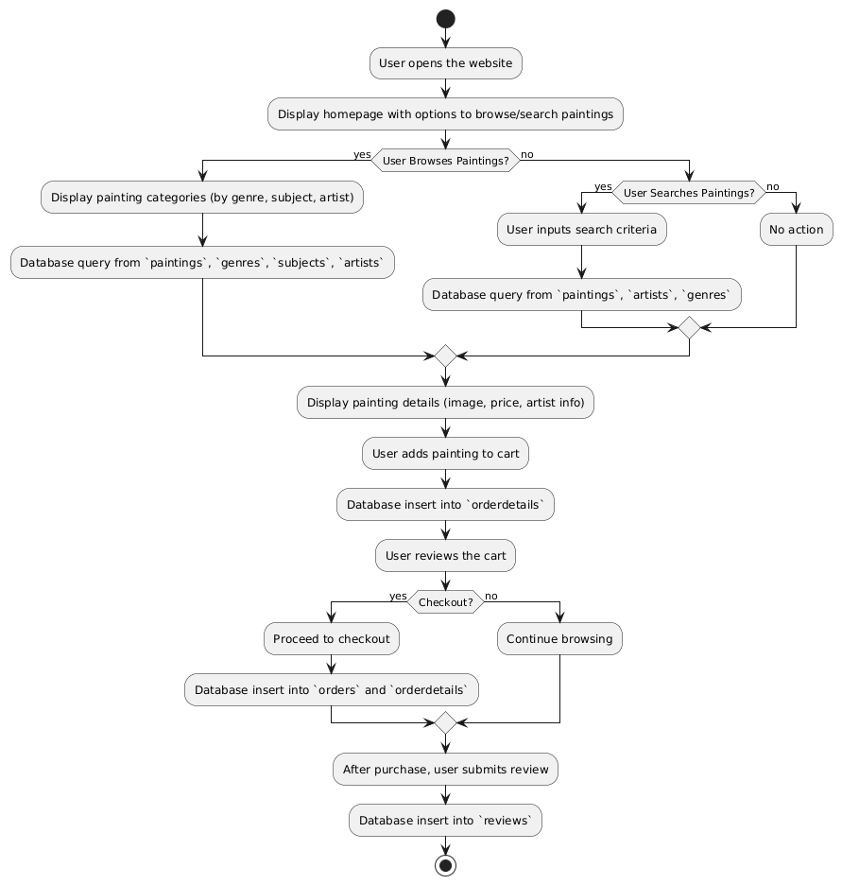

**The flowchart above illustrates the key steps:**

1. Users browse or search for paintings based on categories, artists, or subjects.
2. Paintings are displayed with details such as image, price, and artist information.
3. Users can add paintings to their shopping cart.
4. The system processes the order details and stores them in the database.
5. After purchase, users can submit reviews, which are stored in the reviews database.

### **3.4 Platform Used**

The several platforms and technologies used in the creation and execution of the ArtStore e-commerce platform will be covered in this section. Selecting the right technology is essential to guaranteeing the system's performance, usability, and functionality.

**Tools & Technologies:**

1. **Framework for Web Development:**

* **PHP**: This popular server-side programming language, which is well-known for its adaptability and effectiveness in managing dynamic content and database interactions, is used to construct the ArtStore's backend.

1. **System for Managing Databases:**

* **MySQL**: MySQL is used for managing and storing data. In order to maintain data integrity and security, it offers a strong relational database system that facilitates the organization of data about paintings, users, orders, and reviews.

1. **Technologies for the front end:**

* **HTML and CSS**: HTML is used to organize online pages, and CSS is used to style and arrange them, improving the platform's overall look and user interface.
* **JavaScript**: JavaScript is used for client-side scripting, which makes use of capabilities like form validation and asynchronous queries to improve user experience and enable dynamic interactions.

1. **Libraries and Frameworks:**

* **Bootstrap:** With the help of the front-end framework Bootstrap, responsive and mobile-friendly interfaces can be designed, giving the ArtStore a consistent user experience across a range of devices.
* **jQuery**: jQuery makes it simpler to create dynamic features by streamlining event processing, animation, and HTML page traversal.

1. **Environment for Development:**

* **XAMPP**: With the help of this software package, developers may test and run their PHP applications locally before deploying them. It includes Apache, MySQL, and PHP.

**Deployment**: To handle user traffic and data storage, the ArtStore platform is housed on a cloud server that offers scalability and dependability. This configuration guarantees that users can always access the platform.

**References**

1. W3Schools. (n.d.). PHP Tutorial. Retrieved from https://www.w3schools.com/php/  
   A comprehensive guide to PHP programming, covering basic to advanced topics.
2. PHP.net. (n.d.). PHP Manual. Retrieved from <https://www.php.net/manual/en/>  
   The official PHP documentation, detailing all functions, features, and best practices.
3. Stack Overflow. (2024). PHP Best Practices. Retrieved from <https://stackoverflow.com/questions/tagged/php>  
   A community-driven resource providing answers and discussions on PHP best practices and common issues.
4. Laracasts. (n.d.). PHP Development Tutorials. Retrieved from <https://laracasts.com/>  
   Online tutorials and resources focused on PHP development, especially in the context of Laravel.
5. GeeksforGeeks. (2024). PHP | Introduction to PHP. Retrieved from https://www.geeksforgeeks.org/php-introduction/  
   A beginner-friendly introduction to PHP, covering key concepts and features.